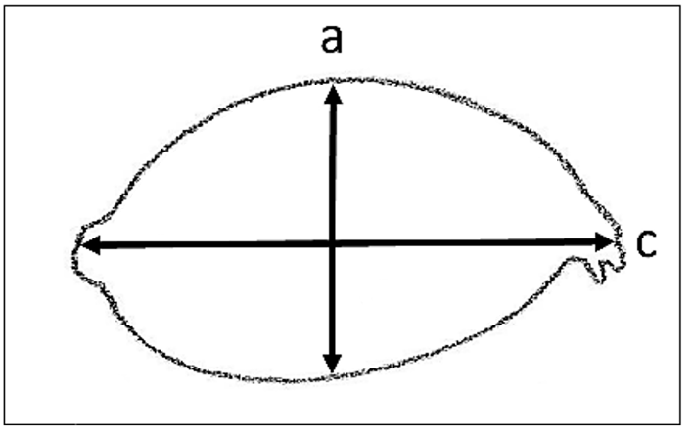
Figure 1. Babassu fruit’s shape. Polar and longitudinal diameters represented by ‘a’ and ‘c’ respectively.

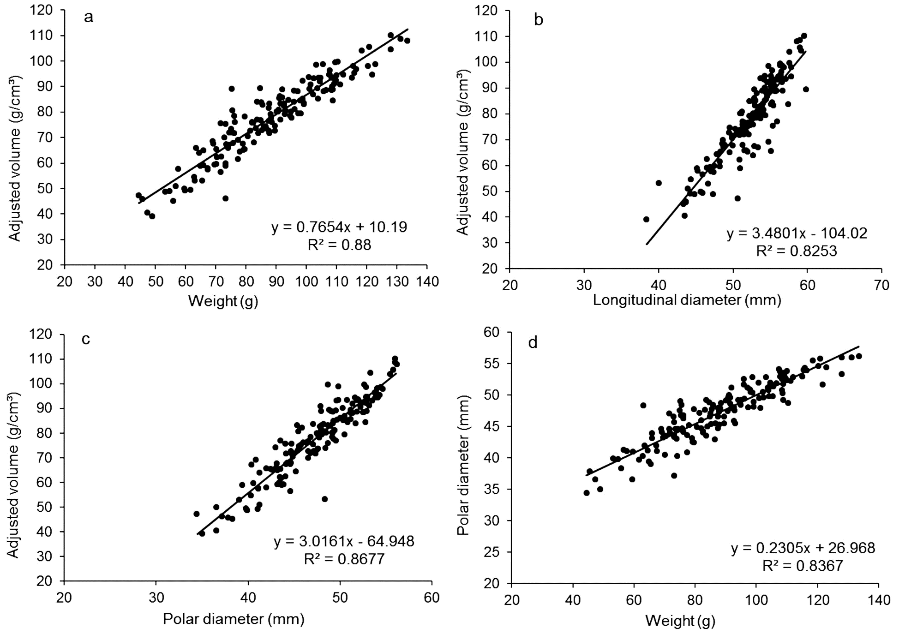
Figure 2. Relationships between the adjusted volumes (Avol) and (a) weight; (b) and longitudinal diameter; (c) and polar diameter; (d) weight and polar diameter.

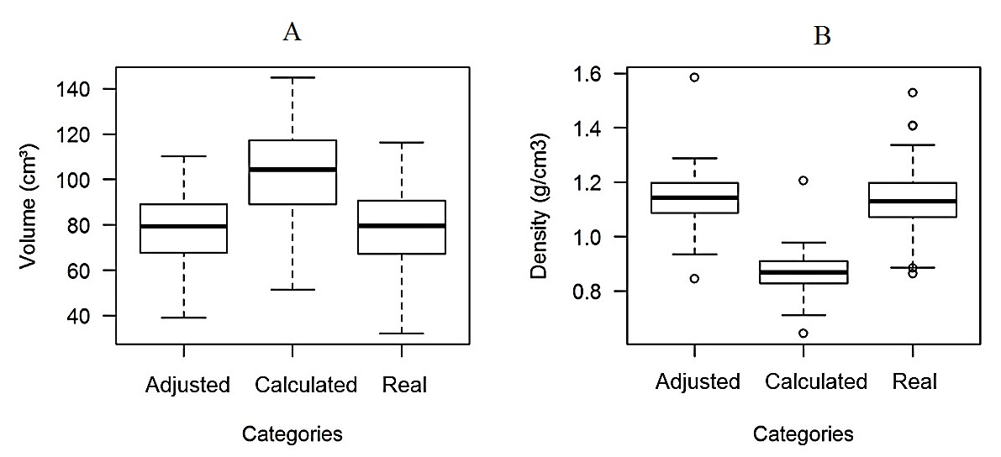
Figure 3 – Data distribution among the categories of the volumes (A) and densities (B).

