PREDICTABLE, AND PRICE VOLATILITY RISK IN THE BRAZILIAN MARKET INTEGRATION OF SHRIMP

ABSTRACT
The present paper has the purpose of investigate the dynamics of the volatility structure in the shrimp prices in the Brazilian fish market. Therefore, a description of the initial aspects of the shrimp price series was made. From this information, statistics tests were made and selected univariate models to be price predictors. It´s presented as an exploratory research of applied nature with quantitative approach. The database was collected through direct contact with the Society of General Warehouses of São Paulo (CEAGESP).The results showed that the great variability in the active price is directly related with the gain and loss of the market agents. The price series presents a strong seasonal and biannual effect. The average structure of price of shrimp in the last 12 years was R$ 11.58 and external factors besides the production and marketing (U.S. antidumping, floods and pathologies) strongly affected the prices. Among the tested models for predicting prices of shrimp, four were selected, which through the prediction methodologies of "One Step Ahead" with 12 periods horizon $y_{t}$, proved to be statistically more robust. We concluded that the dynamic pricing of commodity shrimp is strongly influenced by external productive factors and that these phenomena cause seasonal effects in the prices. Through statistical modeling is possible to minimize the risk and uncertainty embedded in the fish market, thus, the sales and marketing strategies for the Brazilian shrimp can be consolidated and widespread.

Keywords: Volatility. Integration pricing. Previsibility. Shrimp

RESUMO
O presente trabalho tem como proposta geral investigar a dinâmica da estrutura de volatilidade nos preços do camarão no mercado brasileiro de pescados. Para tanto, foi feita a descrição dos aspectos iniciais da série de preços do camarão. A partir dessas informações, foram realizados testes estatísticos e selecionou-se modelos univariados para funcionarem como previsores de preços. Apresenta-se como uma pesquisa exploratória de natureza aplicada com abordagem quantitativa. O banco de dados foi coletado através de contato direto com a Companhia de Entrepostos e Armazéns Gerais de São Paulo (CEAGESP). Os resultados apontaram que a grande variabilidade nos preços do ativo se relaciona diretamente com os ganhos e perdas dos agentes de mercado. A série de preços apresenta um forte efeito sazonal e semestral. A média de preço do camarão dos últimos 12 anos foi de R$ 11,58 e, provavelmente, fatores externos à produção e a comercialização (antidumping americano, enchentes e patologias) afetaram fortemente os preços. Dentre o conjunto de modelos testados para a previsão de preços do camarão, foram selecionados quatro, os quais, através do procedimento de previsão de um passo à frente de $y_{t}$ de horizonte 12, revelaram-se estatisticamente mais robustos. Concluiu-se que a dinâmica de preços da commodity camarão é influenciada fortemente por fatores produtivos externos e que esses fenômenos causam efeitos sazonais nos preços. Através de modelagem estatística é possível minimizar o risco e a incerteza que estão incorporados no mercado de pescados, deste modo, as estratégias de venda e comercialização para o camarão brasileiro podem ser consolidadas e difundidas.

Palavras-Chave: Volatilidade. Integração de preços. Previsibilidade. Camarão.

RESUMEN
Este trabajo tiene como propuesta general investigar la dinámica de la estructura de la volatilidad en los precios del camarón en el mercado de pescado de Brasil. Por lo tanto, la descripción fue hecha de los aspectos iniciales de los precios del camarón serie. A partir de esta información, se realizaron pruebas estadísticas y se selecciona modelos univariantes para actuar como predictores precios. Se presenta como una investigación exploratoria de carácter aplicado con enfoque cuantitativo. La base de datos se recogieron a través del contacto directo con la Sociedad de almacenes y Almacenes Generales de São Paulo (CEAGESP). Los resultados mostraron que la alta variabilidad en los precios de activos es directamente las ganancias y pérdidas de los agentes del mercado relacionados. La serie de precios muestra un fuerte efecto estacional y semi. El precio medio de camarones últimos 12 años fue de R$ 11,58 y, probablemente, factores externos a la producción y comercialización (US antidumping, inundaciones y enfermedades) precios fuertemente afectadas. Desde el campo de los modelos probados para predecir los precios del camarón, se seleccionaron cuatro, que, por procedimiento de predicción un paso adelante $y_{t}$ de horizonte 12, han resultado estadísticamente más robusto. Se concluyó que la dinámica de los precios de los productos de camarón están fuertemente influenciadas por factores externos de la producción y que estos fenómenos causan efectos estacionales en los precios. A través de modelos estadísticos es posible minimizar el riesgo y la incertidumbre que se incrusta en el mercado de pescado, por lo tanto las ventas y estrategias de marketing para los camarones brasileños pueden consolidarse y difundirse.

Palabras-clave: La volatilidad. Precios de integración. La previsibilidad. Camarón.

- INTRODUCTION
In recent years, the global economy has been showing an intense process of financial, production and commercial markets globalization. This way, knowing the theoretical framework and structural information that shape the panorama and design scenarios of the fishing market, is essential to understand the size and dynamics of this business so representative in the international scope.
According to Pimentel, Almeida and Sabbadini (2004), in the late 80s and early 90s, there was a change on the Brazilian trade politics, characterized by what would later be called the Brazilian trade liberalization, in which, by reduction in tariff barriers to tariff order, the country opened up to imports and allowed its industry to compete with products made abroad.
Other relevant positions in this period also contributed to Brazil's export performance, as the implementation of the MERCOSUL and monetary reform in the country, responsible for an extensive period of overvalued national currency and later currency devaluation, that besides adding volatile commercial expectations, affected the domestic exporter, mainly agricultural, farming and aquaculture exports, to the extent they did vary the prices realized by domestic producers as well as consumers by external performance.
As a result of these and other factors, in recent years the Brazilian seafood market has been developing, evolving and modernizing, standing out as an activity of high economic and social value, with a trend of rapid growth in the short and long terms. By the year 2005 the trade balance had a surplus of fish, and from 2006, with the decline in exports, the balance became negative in 2011 and showed a negative balance of $ 1 billion (MDIC, 2012) which shows that the domestic market has shown a capacity for absorption of fish production.
The amplitude of the internal market contributed to the dynamic nature of this industry in Brazil, with the incorporation of modern production technologies to satisfy the demands of this market. The generation and technology adoption by producers have as an incentive the expected return, and the relationship of the price of inputs and the analysis of product price are primary elements in decision making.
Thus, the analysis of prices and their fluctuations is one of the main tools for planning and evaluation of agricultural activities, since it is a decisive factor in the choice of business opportunities. The price formation as the controlling element of the exchange mechanism, is of singular importance to the Government in the formulation and application of efficiently directed policies to the fishing sector.
The fishing commodities highlighted by rapid expansion of production and involvement in international trade, with an export volume in 2007 of 65 thousand tons, equivalent to 388 million dollars. Despite the reduction in the exports’ growth, the volume and values ​​were of the same order in the two following years (ABCC, 2012).
Shrimp farming is taken in this scenario as the main commodity imported into the Brazilian market. After successive declines in production (2003-2005), the production of farmed shrimp remained stable from 2005 to 2009 and showed significant increase in 2010, demonstrating the resilience of the sector, as can be seen in figure (1).

Figure 1 – Performance of Brazilian Shrimp Farming from 1998 to 2010 estimative ABCC
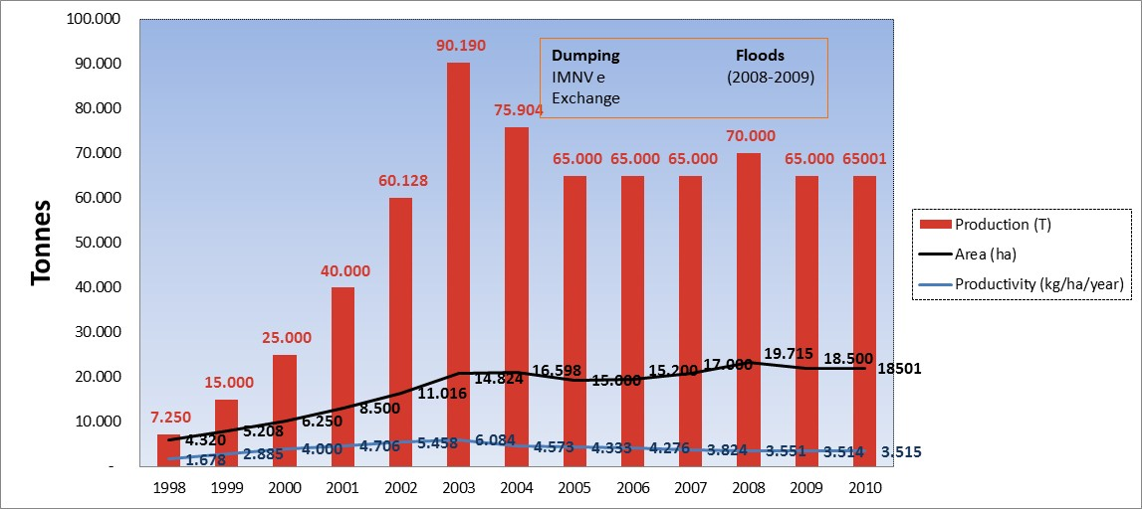
Source: Adapted from ABCC. Available at www.abccam.com.br

The current market has shown declines in fish exports from Brazil (see Figure 2), demonstrating the importance of the notorious farmed shrimp on the agenda of Brazilian exports of fish.

Figure 2 - Performance of exports fish from Brazil in volume and value 2003-2010
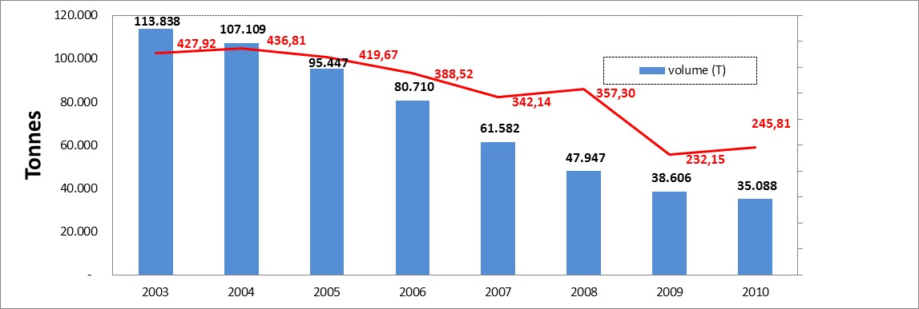
Source: Adapted from Aliceweb *, 2011. Available at: <Aliceweb.desenvolvimento.gov.br>
* Official Site of foreign trade statistics of the Brazilian government.

This commodity’s import has been increasing strongly year after year (Figure 3), which highlights the urgent needs of investments in the country in the aquaculture industry as a way to meet the growing demand for these products.

Figure 3 - Performance of imports of fish in Brazil in volume and value 2003-2010
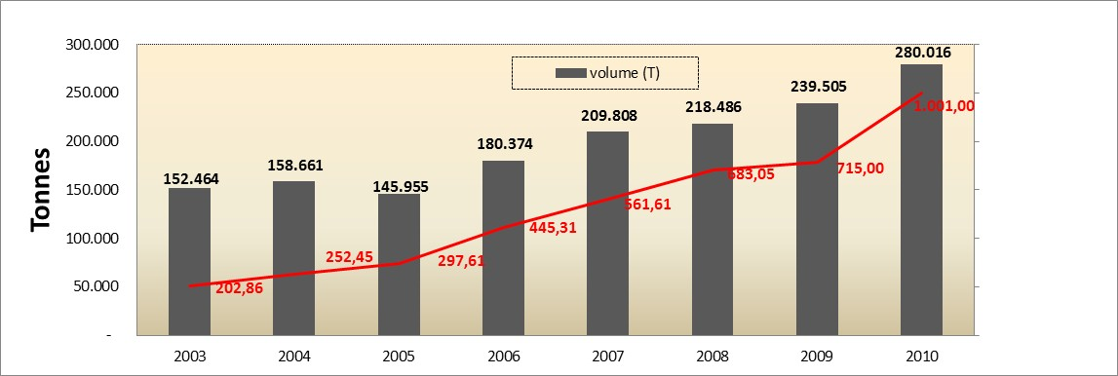
Source: Adapted from Alice web *, 2011. Available at: <aliceweb.desenvolvimento.gov.br>
* Official Site of foreign trade statistics of the Brazilian government.

Even with this scenario, the Shrimp farming has manage to flow its production into domestic market, but a long with uncertainty and instability of the sector the risk, for new investors or entrepreneurs is preeminent. Aware of the different reactions and different attitudes toward risk, producers and traders of shrimp have created a good atmosphere to conducting business.
The econometric modeling time series forecasting prices and risks can lead to the determination of the volatility inherent in the formulation of financial strategies into fish market. By studying the price series of the shrimp, the manipulation of univariate and multivariate models, more accurate statistical data to forecast prices and causality analysis or long-term balance between it and other commodities can be obtained. Based on this information, the agents of this market may best attribute prices to their expectations about the behavior of prices and market risks.
However, shrimp farmers still lack tools and sophisticated studies of price behavior, long-term relationships between assets of the fishing market and more robust models for conducting prices forecasting. It is from this perspective that the present study intends to investigate the behavior of the structural dynamics of volatility in the prices of commodity shrimp in the Brazilian fish market.
Given the volatility characteristic of the commodity's price analyzed in this research, it is essential for producers and other participants in the production and marketing chain that mechanisms to transfer risk among participants in the chain are developed; such perspective has been the motivated of this study.
This paper is divided into the following sections: the first addresses the overall context of the shrimp market and the productive performance of this commodity in the Brazilian scene. The second section presents the empirical review of studies and research produced in Brazil and the world on modeling of prices, volatility of commodity and asset pricing. In the third section, the general methodological aspects of research and modeling used with the data obtained are presented. The fourth section presents the main results and findings of research and finally, the fifth section reveals the findings, the study limitations and integrating the results with the expectation with market participants.

2 – EMPIRICAL REVIEW
In literature several studies using time series as methodological tools for forecasting and price transmission, projected values at risk and identification of long-term relationships can be found.
Sabes and Alves (2008) investigated the peanut agribusiness by comparing seasonal patterns of price behavior (1996-2005) and found that seasonal crop and intercrop, influence the behavior and the dispersion of prices paid to producers in the peanut market. Adami and Miranda (2011) studied the process of price transmission in the Brazilian rice market and concluded that the marketing agents from rice production chain may establish marketing strategies between the two markets (Rio Grande do Sul - RS and Mato Grosso- MT) more safety when considering that stimulus or discouraging price in RS will affect prices in the MT market.
Campos et al. (2008) analyzed the causality of cattle prices in different squares in the Southeast and Midwest regions of Brazil, where they met the result that there is prevalence between the squares of a dynamic and flexible system for transferring information, and even that the two regions are not commercially relate to each other, their prices are linked because both market with a third region.
Campos (2007) gave emphasis to the analysis of the price volatility of agricultural products in Brazil, and concluded that the cyclical and seasonal fluctuations or the prices of agricultural products caused as much instability in the producer’s income as in the urban consumer’s expenses. Furthermore, the author pointed out that the information about volatility is important for the forecasts of the conditional variance of commodity prices, in an indefinite horizon. He also stressed that the high risk of price and income associated with the markets for these products can provide producers and other major economic actors profits in certain periods, in addition to huge losses and even exit the market in adverse situations.
By using the ARCH approach, Teixeira et al. (2008) investigated the dynamics of the return volatility on cocoa cattle and coffee commodities. These authors found that the volatility of the return of cocoa is persistent and indicates that shocks take a long time to dissipate. Overall, for the three commodities, studied the volatility of returns is persistent and shocks take a long time to dissipate, and positive and negative shocks have a different impact on volatility. It was also demonstrated that the estimation results for the conditional mean and volatility of the returns of coffee, indicate that a shock in the series of returns for various periods will effect the volatility of these returns.
Concerning volatility, the study of Pereira et al. (2010), aimed at benchmarking the returns of Brazilian agricultural commodities, where returns of coffee and soya are characterized by asymmetric responses to the positive and negative shocks, although the leverage effect has not been identified and VaR measures showed the greatest lost potential to coffee producers, followed by soya and cattle.
Kreuz and Souza (2006) verified production costs, return expectation and risk of Garlic agribusiness in southern Brazil. That authors found that in the globalized market economies there is no way to prevent, without retaliation, imports. Thus, the viability of Brazilian garlic, mostly from the South, depends on two basic strategies: 1) more research and development to productivity had increased and 2) choose a product differentiation investing in purple garlic which is already the Brazilian consumer’s preference.
Moreira et al. (2010) analyzed the agribusiness market’s risk management in the context of agribusiness cooperatives and through this study has highlighted that the options to improve the management of market risks (risk-return analysis) and the influence of agricultural cooperatives in this context, can be made by means of risk-return analysis, performed according to the Markowitz mean variance model. After the application of this model, an efficiency frontier has been traced which allowed to generate two scenarios of efficient portfolios (in one of the scenarios was possible greatly decrease the risk associated with production levels of the portfolio 2006 and in the other, it was possible to increase the total gross margin for the portfolio maintaining the level of risk practically stable).
On the Shrimp market, the majority of published studies refers only to the qualitative aspects of production and prices, such as Valenti (2002), Carvalho et al. (2007), Pincinato (2010) and Ferdouse (2011). On the other hand, the work of Sousa Jr. et al. (2007) and Felipe et al. (2013) stand out among the works published because they deal with the behavioral aspects of national and international shrimp prices by univariate and multivariate modeling.
As it was said before, it can be seen that the methodology of time series is widespread in academia, but its use is restricted only to a few commodities of agribusiness and agriculture. From the development of this study it is hoped that the information contained and presented may function as a basis for formation of marketing strategies shrimp in the Brazilian shrimp market.
Finally, this work was developed with the prospect of adding to the scarce literature on studies of volatility in the aquaculture sector from a univariate approach applied to the prices of brazilian medium shrimp. Internationally, there are not many records of work with the theme and research that this article which is proposing to do. Some studies found containing fragments of the studies presented here can be seen in Parsons and Colbourne (2000), Khaemasunun [sd] and Harri, Muhammad and Jones (2010) and Sousa Júnior et al. (2007).

3 - GENERAL METHODOLOGICAL ASPECTS
This study is presented as an descriptive research of an applied nature with a quantitative approach through documentary analysis. The price series were extracted from the database of CEAGESP, (Society of General Warehouses of São Paulo).
The series analyzed represent average prices of shrimp in size between 09G-11g, the type Litopenaeus Vannamei, as set by the most liquid asset in terms of the marketing of Brazilian fish. The data correspond to monthly average trading prices quoted by CEAGESP the timeframe from January 2000 to May 2012. The prices collected represent the Brazilian market for shrimp. The CEAGESP collects and the price of those prices at national level. To perform the statistical tests, modeling and forecasting of prices between the price series shrimp, R (R-Project in version 2.14.2) free software was used.
In this study the methodology ADF (Dickey and Fuller, 1979) and the model of Enders (2004) for testing and evaluation of the hypothesis of stationarity of the price series was used.
The univariate model was also applied into the original series of prices of shrimp, deflated in the series and the series of returns for the purpose of describing the behavior of prices. SARIMA processes were used in these price series along with procedures for forecasts $y_{t}$ 12 steps forward and one step ahead of $y_{t}$ de horizon 12 Methodology Box-Jenkins (1976), into the sample with the previous twelve observations.
To prevent unusual phenomena would determine biases in the estimates if they were not controlled, a study was made of structural break in the period 2010-2012, due to the strong break in prices in this period. Qualitative variables that could cause biases in the estimates were modeled by inclusion of seasonal dummies variables.

3.1 Model for price forecasting
3.1.1 Seasonal ARIMA or SARIMA
Following the concept proposed by Nelson (1973) and considering that an auto-regressive stochastic model purely seasonal SAR (P) of order P, one $y_{t}$ stationary series is regressed on its lagged values earlier in multiples of s:
$y_{t}=ϕ_{1}y_{t−s}$ + $ϕ_{2}y_{t−2s}+…+ϕ_{p}y_{t−Ps}+ε_{t}$

In turn, the seasonal pattern of pure moving average SMA (Q) of order q can be represented algebraically by:
$y_{t}={ε_{t}−θ}_{1}ε_{t−s}{−θ}_{2}ε_{t−2s}{−…−θ}_{Q}ε_{t−Qs}$

Seasonal combining the auto-regressive moving average terms and has a SARMA (P, Q), expressed in the form:
$y_{t}=ϕ_{1}y_{t−s}$ + $ϕ_{2}y_{t−2s}+…+ϕ_{p}y_{t−Ps}+ε_{t}−θ_{1}ε_{t−s}{−θ}_{2}ε_{t−2s}{−…−θ}_{Q}ε_{t−Qs}$ (3)

Similarly, as in Examples (models) regular, it can be shown that:
$$Φ_{P}\left(B_{s}\right)={1−ϕ}_{1}B_{s}{−ϕ}_{2}B_{2s}{−…−ϕ}_{P}B_{Ps}$$
$$Θ_{P}\left(B_{s}\right)={1−θ}_{1}B_{s}{−θ}_{2}B_{2s}{−…−θ}_{Q}B_{Qs}$$

For a SAR (P) model, one has:
$$Φ_{P}\left(B_{s}\right)y_{t}=ε_{t}$$

Already for a SMA (Q):
$$y_{t}=Θ_{Q}\left(B_{s}\right)ε_{t}$$

and the SARMA model (P, Q):
$$Φ_{P}\left(B_{s}\right)y_{t}=Θ_{Q}\left(B_{s}\right)ε_{t}$$

In addition, the auto-regressive and moving average, seasonal models may also be manipulated to non-stationary series, at the time d-th difference leads to seasonal series stationarity transformed. This occurring, the model is seasonally integrated order will be called SARIMA.
The combination product regular seasonal stochastic components model itself is represented in SARIMA (p, d, q) x (P, D, Q) can be synthesized in the following manner:
$ϕ_{p}\left(B\right)\left(1−B\right)$^{d}$Φ_{P}\left(B_{s}\right)\left(1−B | | s\right)$^{D}$y_{t}=θ_{q}\left(B\right)Θ_{Q}\left(B_{s}\right)ε_{t}$ (4)

Where it is known that:
$ϕ_{p}\left(B\right)$ = the regular operator coefficients of autoregression, whose order is p.
$\left(1−B\right)$^{d} = operator ¬D-th regular difference.
$Φ_{P}\left(B_{s}\right)$ = operator coefficients of seasonal autoregression, whose order is P.
$\left(1−B | | s\right)$^{D} operator D = D-th seasonal difference, with periodicity s.
$θ_{q}\left(B\right)$ = operator coefficients of the regular moving average of order q.
$Θ_{Q}\left(B_{s}\right)$ = operator coefficients of seasonal moving average of order Q.

The process of obtaining the SARIMA model follows the same procedures as the Box-Jenkins methodology used to meet the non-seasonal ARIMA model. This indicates that the SARIMA, considering the observance of the behavior of autocorrelation (AFC) and partial autocorrelation (PACF), however, observed seasonal lags (monthly, weekly, daily serials, etc.).

4 - DISCUSSION AND ANALYSIS OF THE RESULTS
4.1 Initial inspections in the price series of the Brazilian medium shrimp
4.1.1 Graphical display of the original price series

Figure 4 - Original Series average price of shrimp (y= Prices in Reais - R$)
Source: Survey data.

Through a quick visual inspection of the prices of Brazilian medium shrimp, one can see that the series presents a variation in prices between the years 2000 to 2012. The figure (4) suggests non’stationarity of prices, confirmed in table (4) where the average prices of assets where the average prices of assets in the last one hundred forty-nine months are presented.
Table 1 – Average Brazilian shrimp price
Year | Middle Price
2000 | R$ 8.93
2001 | R$ 10.21
2002 | R$ 8.72
2003 | R$ 9.05
2004 | R$ 10.07
2005 | R$ 13.36
2006 | R$ 13.88
2007 | R$ 11.23
2008 | R$ 11.53
2009 | R$ 11.85
2010 | R$ 13.34
2011 | R$ 14.84
2012 | R$ 16.18
Source: Survey data.

The great variability in prices over the years was caused among other factors, by the american antidumping measure, where production went from 76,000 tons to 65,000 in 2005 (see figure 1), which resulted in a loss of productivity that was 6,084 (kg / ha / year) in 2004 to 3,515 (kg / ha / year) in 2010 (see figure 1), the decline in exports both in volume and in value (decline since 2003 - see figure 2) and the growth of imports both in volume and in value (increase since 2006 - see figure 3), which do generate foreign currency and devaluation of the brazilian currency in international trade in commodities.
Based on information from the figure (4) and table (1), traders and investors can have some clarification about the variation in the price of shrimp. Where the higher valuation of the asset was given only in 2012 when the average price was R$ 16.18 and the reflection of the American added measure with the flooding in yields (due to the heavy rain) was the devaluation of the average price of shrimp which was R$ 13.36 and R $ 11.85 went to in 2009.
All this means that voluptuous investments in commodity shrimp did not bring significant earnings on invested capital at that time (2005-2009). The recovery in average prices is only noticeable from 2010 onwards.
Continuing with the initial inspection and a detailed statistical description of the general aspects of the series, the price decomposition was performed under the temporal order in an additive graph as we can see in figure (5).

4.1.2 Additive decomposition of shrimp prices in temporal series
Figure 5 - additive decomposition of shrimp prices in temporal series
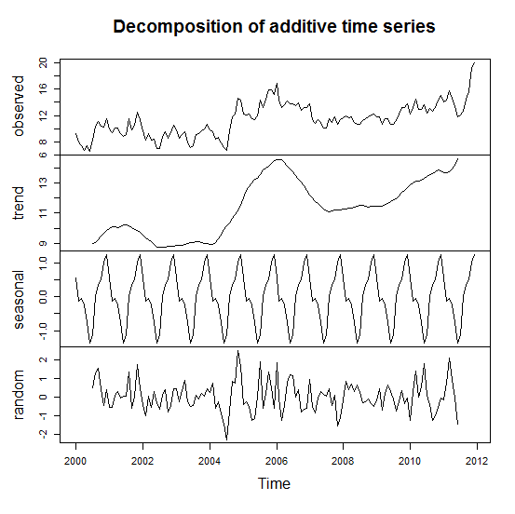
Source: Survey data.

The graph of additive decomposition allows a better insight into the initial price dynamics. Price variability is shown in the first quadrant of the figure (5). In the second quadrant, it shows the estimated trend of the series of prices which presents an increasing behavior. In the third quarter of the same graph, estimated effects of seasonality in prices can be viewed. It’s worth noting that the evidence of nonstationarity was confirmed by ADF test and can be seen in the figure below.
Table 2 – Augmented Dickey-Fuller Test

Augmented Dickey-Fuller Test
Dickey-Fuller = -3.4324
p-value = 0.05187
____________________________________________________
*Alternative hypothesis: stationary

Source: Survey data.

The last quadrant shows a perspective view on the random term of the series of prices, which in turn, shows a great variability, but a reasonably stable balance (indication of stationarity). For a more rigorous inspection, a test on the first difference of the price series was performed (see figure 6).

4.1.3 Graphical Inspection of the first difference of the shrimp prices series (dy)
Figure 6 - First-difference of the Shrimp prices series
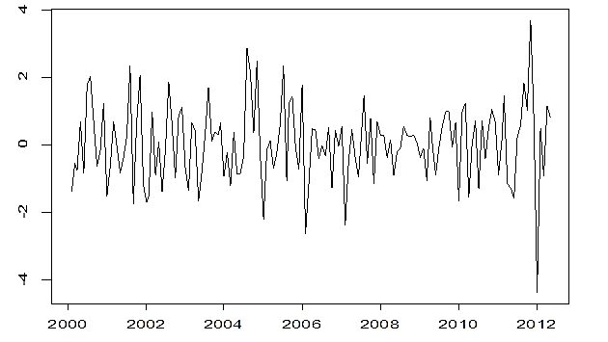
Source: Survey data.

The first difference of the original price series appears to be stationary, which will be checked with other inspections and formal statistical tests before making inferences about behavior and temporal dynamics of the price series.
As follows autocorrelation functions (ACF) and partial autocorrelation (PACF) were examined, which can be seen in figure (7) and (8). The behavior of these functions indicates the models to be used, as well as assists in the use of unit root tests to confirm the stationarity.
4.1.4 Autocorrelation Function - ACF -for the lagged shrimp price series (dy)

Figure 7 - ACF correlogram for the lagged shrimp prices series (dy)

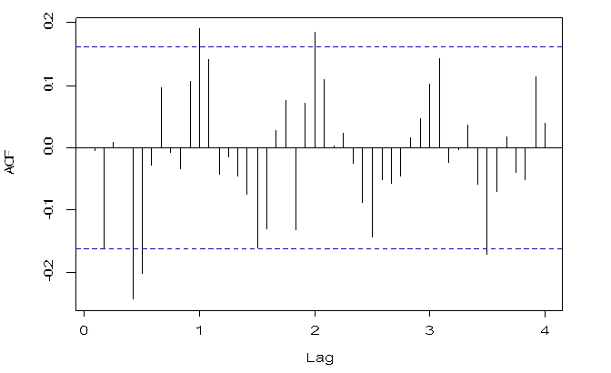
Source: Survey data.

The ACF function is the graph of autocorrelation against the lag. In different series (dy) one realizes that the problem of autocorrelation data was well resolved when it was originally making a difference in the number of shrimp prices and information correlated over time are minimized.
When one takes a difference and the ACF decays exponentially fast, reaching almost zero in the first lags, it is the sign that we can work with a simple model AR (1) .For the price series under study, the AR model (1) is a good candidate to be chosen for modeling and forecasting prices, but this is still not enough to choose it, because the effects of seasonality were not resolved, as it was appointed by the initial inspection in (5) and the models this modeling are sought are those that produce waste in the form of white noise.
Next, a graphical inspection will be done on the partial autocorrelation function for the number of shrimp prices with a lag, once we saw earlier, that with a difference, it may reach the stationary lagged series (see figura 8).

4.1.5 Autocorrelation Partially function PACF - for the lagged shrimp price series (dy)

Figure 8 - PACF correlogram for the different shrimp price series (dy)
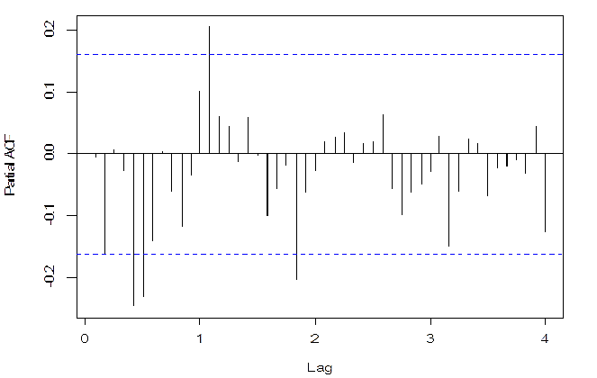
Source: Survey data.

The PACF shows the partial autocorrelations, which measure the correlation between the value of $X_{t}$ e $X_{t−k}$, the influence of the discounted values $X_{t−1}$to $X_{t−k+1}$, and are obtained by the equations Yulle-Walker.
It is observed that only the lag 1 autocorrelations are significant, reinforcing the use of an AR (1). As the ACF and PACF provide an indication of an autoregressive model of order 1, we tested the non’stationarity of the lagged series through the Dickey-Fuller test where the hypothesis of non-stationarity is rejected at the level of 5% of significance. Considering that the series can be considered stationary, the integration order is zero, that is, d = 0.
Completed the initial analysis on the general aspects of the Brazilian shrimp, it is possible, from this moment, to go over the univariate and multivariate price analyzes , aiming to discover which univariate models for conducting price forecasts and econometric study of the series are good. The research will also investigate whether the Brazilian shrimp influenced or influences prices of American shrimp, depending on the trade relations between Brazil and the USA at the beginning of exports of Brazilian shrimp between the years 2000-2004.

4.2 Univariate Modelling (SARIMA)
Two models were obtained from the Box-Jenkins methodology based on the repetition of three steps (1: identification, 2: estimation and 3: diagnosis) until it finds a suitable model according to statistical criteria.
The first step is to identify one or more models of the ARIMA class (seasonal or SARIMA) having as main tools the estimated autocorrelations (original and partial), punitive information criteria (AIC and BIC) and augmented Dickey-Fuller test, besides the graphical inspections. The models are estimated in step 2. At the final stage of diagnosis, coefficients and their standard errors are valued, where the main statistical characteristics of the waste in each model should appear as white noise.
At diagnosis, similar tools to the first stage were used, but applying the waste instead of the original series: estimated autocorrelations (original and partial), the Box-Ljung test and graphical inspection. In this second step, the previously selected models are changed or dropped or added to new models and the process can be repeated two or three times until you have a small number of suitable models. In case of more than one final model, forecasts can be used for possible tiebreaker.

- Modeling with the original series (w and y)
The model resulting from the analysis described in the introduction based on the number of $y_{t}$ prices was a SARIMA (13,1,0)(1,0,0)₁₂, specifically:

$\left(1+0,17B^{2}+0,25B^{5}−0,23B^{13}\right)\left(1−0,22B^{12}\right)∆y_{t}=ε_{t}$ (1)
Table 2 – Model results of the Sarima (13,1,0)(1,0,0)₁₂
Coefficients: | ar1 | ar2 | ar3 | ar4 | ar5 | ar6 | ar7
 | 0 | -0,1703 | 0 | 0 | -0,2547 | 0 | 0
S.E: | 0 | 0,0155 | 0 | 0 | 0,0165 | 0 | 0
 | ar8 | ar9 | ar10 | ar11 | ar12 | ar13 | sar1
 | 0 | 0 | 0 | 0 | 0 | 0,2304 | 0,2171
S.E: | 0 | 0 | 0 | 0 | 0 | 0,0172 | 0,0222
 | 1,092
AIC: | 444,73
Source: Survey data.

Thus, the stationarity of the original price series was obtained after a simple difference and the model produces waste in the form of white noise with an estimated variance of 1.1. All estimated coefficients of the model have p-value less than 1%. The waste of the models showed a strong adherence to the normal distribution (quantile viewing and usual normality tests) and no additives or innovation outliers were detected.
It was also observed that a second model SARIMA, this time with a seasonal difference, showed similar results, but lower in terms of predictions. On the other hand, regarding to the deflated series, the opposite happened, in other words, the SARIMA model with seasonal difference was higher (see next section).

Figure 9: Forecast $Y_{t}$ 12 steps ahead. The dashed line represents the point forecast and the dotted lines represent the limits of the forecast range of 95%. rEMQP 2.6 and MAPE of 13.2%
Source: Survey data.

Shortly thereafter, the forecast of the series into two scenarios (forecast $y_{t}$ 12 steps forward and one step ahead prediction of $y_{t}$ de horizon 12), where in both cases, we used the model described above and forecasts were made based on it of the previous twelve observations (within the sample).
The first procedure (figure 9) is more robust and provides forecasts for one year ahead, i.e., twelve steps in relation to the last observation. Through a quick visual inspection, it is observed that the predictions show strong deviations from what happens in reality. The mean absolute percentage error (MAPE), which represents the absolute difference between the predicted and actual values, was 13.2%, which indicates a high degree of forecast error. Besides MAPE presented in high value, the first procedure also showed a mean squared error (rEMQP) 2.6. It is worth noting that it is an unusual and difficult period to predict for the observations 2012: 11 and 2012: 12, due to the present a strong structural break in the behavior of prices.
In the second procedure (figure 10), predictions were made by the method step by step, where each prediction is made in isolation, just considering the previous prediction, thus the ASM showed a value of 2.8%, which according to Heizer and Render (2004), indicates an acceptable value for prediction errors as well as an average squared error (rEMQP) of 0.6 and a better quality of prediction regarding the procedure (1).

Figure 10 - Forecast one step ahead of $y_{t}$ de horizon 12. The dashed line represents the point forecast and the dotted lines represent the limits of the forecast range of 95%. rEMQP 0.6 to 2.8% MAPE
Source: Survey data.

- Modeling with deflated series (w and y)
For deflating of the original shrimp price series, we used the IGP-DI based in 2011: 12 (figure 11). The SARIMA (1,1,0) (1,1,0) model produced errors similar to white noise (see table 2),
$\left(1+0,19B\right)\left(1+0,54B^{12}\right)∆∆_{12}y_{t}=ε_{t}$ (2)

resulting in waste with estimated variance of 3.2. The autoregressive coefficient is significant at the 5% level and the seasonal autoregressive coefficient is significant at the 1% level.

Table 3– Model Results Sarima (1,1,0)(1,1,0)
Coefficients: | ar1 | sar1
 | -0,1916 | -0,5390
S.E:  $$σ^{2}:$$ | 0,0846 | 0,0812
 | 1,585
Coefficients: | ar1 | sar1
Source: Survey data.

The residues of the models showed a strong adherence to the normal distribution (viewing quantile and the usual normality tests) and nor additive or innovation outliers were detected.

Figure 11 - Original series (solid line) and deflated series (dashed line)
Source: Survey data.

Just as in the original series of prices, price forecast was held for the deflated series according to the “12 steps ahead” procedures (see figure 12) and “one step forward with the horizon of 12 periods” (see figure 13).
For the two predictions (figures 12 and 13), it can be seen that the procedure “One Step Ahead” showed a better quality and adjustment regarding price series.
The prediction error (MAPE) for the procedure “one step ahead” (with horizon of 12 periods) was 4.9% against a MAPE of 10.6% of the “12 Steps Ahead” procedure. In addition to a smaller MAPE, the “One Step Ahead” procedure presented a rEMQP (mean square error) of 0.9 against a rEMQP 2.2 (“12 Steps Ahead” procedure).

Figure 12 - Forecast of 12 steps ahead $y_{t}$. Dashed line represents the forecast point and the traced lines represent the limits of the 95% prediction interval. rEMQP 2.2 and MAPE 10.6%
Source: Survey data.

Figure 13 – “One Step Ahead” forecast horizon $y_{t}$ 12. The dashed line represents the forecast point and the traced lines represent the limits of the 95% prediction interval. rEMQP 0.9 to 4.9% MAPE
Source: Survey data.

c) Modeling with seasonal exponential smoothing
For the original series the Holt-Winters model made the following estimates for the level parameters, trend and seasonality respectively: α = 0.58, β = 0 and γ = 0.49. As for the deflated series a greater weight to reduction in component and seasonal effect level was obtained: α = 0.42, β = γ = 0.01 and 0.70.
This higher value of γ confirms the need to use a seasonal difference when working with the deflated series (see models (1) and (2)). The horizon forecasts 12, both a year ahead as well as a month (step) forward, are inferior to those obtained by SARIMA models (1) and (2).

d) Modeling with the number of returns (percentage change in prices - r)
One of the approaches to the study of asset prices is the continuous modeling of returns, where:
$r_{t}=\frac{L_{n}P_{t}}{L_{n}P_{t−1}}$, illustrated in figure (14).

The resulting model of Box-Jenkins methodology (1976) used in previous sections was a SARIMA (6,0,0) (1,0,0):
$\left(1+0,27B^{5}+0,22B^{6}\right)\left(1−0,22B^{12}\right)z_{t}=ε_{t}$ (3)
Table 4– Results models Sarima (6,0,0)(1,0,0)

Coefficients: | ar1 | ar2 | ar3 | ar4 | ar5 | ar6 | sar1 | intercept
 | 0 | 0 | 0 | 0 | -0,2605 | -0,2192 | 0,2166 | -0,1068
S.E:  $$σ^{2}:$$ | 0 | 0 | 0 | 0 | 0,0801 | 0,0863 | 0,0934 | 0,6353
 | 81,72
AIC: | 1083,09
Source: Survey data.

As in (1), a half cycle seasonal effect in addition to seasonal effects and effects of magnitudes comparable to (1) was observed. The exception would be the lag effect 2 that here was not significant whereas in (1) a $φ_{2}$= -0.17 was obtained. However, this estimate had borderline significance (p-value less than 5%).
For comparison, if it included the autoregressive term of order 2 in (3) we would obtain an estimate of -0.13 with p-value between 5% and 10%.The residues of the models showed a strong adherence to the normal distribution (viewing quantile and the usual normality tests) and nor additive or innovation outliers were detected

Figure 14 – Returns
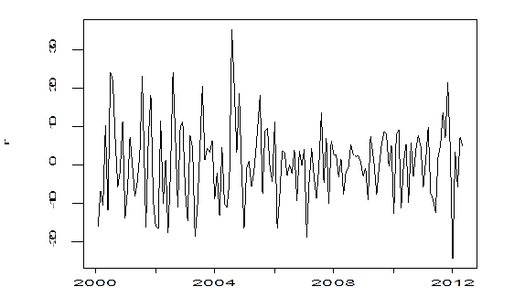
Source: Survey data.

4.3 Volatility
Studies residues (squared) of univariate analyzes described above, in order to obtain a formulation for GARCH waste, in other words, a SARIMA-GARCH for y, indicated no evidence of conditional heterocedasticity.
As shown below (18), the waste does not exhibit strong autocorrelations or partial autocorrelations. The result of the ADF test for residues was -7.6319 with p-value of 0.01, indicating almost constant error variance.

Figure 15 - Function ACF and PACF for waste
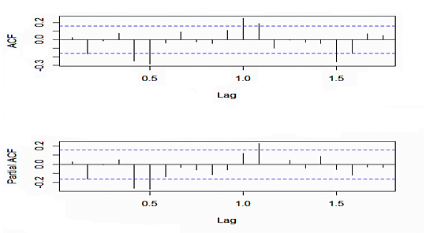
Source: Survey data.

Applying a model SARIMA (6,0,0) (1,0,0), residues resemble white noise as can be seen in figure (16).
Figure 16 - Function ACF and PACF for residues modeled by a SARIMA (6,0,0)(1,0,0)
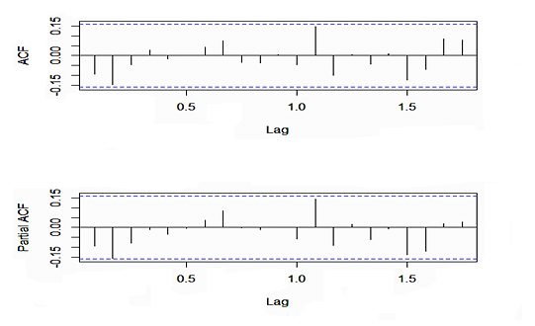
Source: Survey data.

Finally, through the figures (17 and 18), the reason of not using the GARCH model for unconditional mean and volatility of waste can be confirmed, because the SARIMA process (6,0,0) (1,0,0) had shaped waste and expectations of large dispersion around the mean were not confirmed, however, little scatter was found.

Figure 17 - Behaviour of the residue
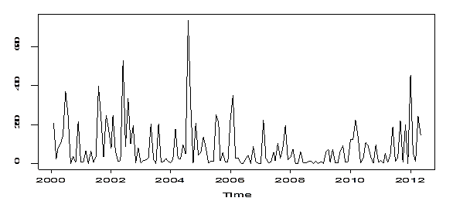
Source: Survey data.

Figure 18 - residues Distribution

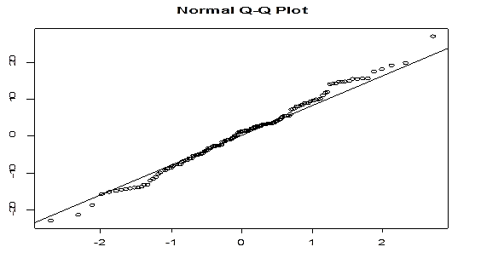
Source: Survey data.

4.4 Integration of search results with the expectations of marketing agents
Through the results presented by this research, the marketing agents of shrimp commodity can view statistical aspects for more efficient investment management from the perspective of risk.
It turned out that, among other factors, after the US government accused Brazilian market to sell their products, goods and services from Shrimp Farming, at a price below its fair value to other countries, marketed shrimp prices experienced a large reduction, approximately 30% (2005-2009). With this measure, several market players have lost large sums of money invested in the production, distribution and marketing of fish.
In addition to this factor, the large amount of incident rainfall and low flows during periods of drought further contributed to the dismal performance of the asset during those four years under discussion. The risk of investing in shrimp commodity also appears in the dependence of producers in relation to inputs such as feed and imported medicines, especially the United States, Spain and China, that is, even if Brazil has hardly any link shrimp export to these countries, there is also a productive dependence with respect to inputs.
To minimize the risk and investment losses on Shrimp Farming, it is required prior knowledge of the peculiarities of this activity, the production techniques, external influences and economic factors that may influence it. Some of this information is presented in this research, because through statistical modeling, four good models to predict prices were discovered, which when applied to the forecasting procedures "One Step Ahead" with $y_{t}$horizont of 12 periods, present results with minor errors prediction, that is, are significant and quite suitable for the realization of modeling and price forecasts. Thus, they can be used as tools for risk management and support the investment decision-making.

5 CONCLUSIONS
In this research we tried to analyze the dynamics of the volatility structure in shrimp commodity prices in the Brazilian fish market. Therefore, univariate statistical modeling was applied to the Brazilian average shrimp commodity prices. Which is used for prediction and modeling of prices, forecast demand and supply, study trends and seasonal effects in price series.
The objectives were achieved and from them important considerations on the volatility, integration of prices and predictability to the Brazilian market for shrimp can be made. The description of the initial aspects of the series shrimp prices, which confirmed the existence of a strong half-yearly seasonality in prices was made.
It was found that the average price structure for research was R$ 11.58, with occasional fluctuations mainly from 2004. One of the probable causes of these fluctuations, among other factors, was the American anti-dumping measure, which aimed to ensure the American products conditions of competition with Brazilian ones, since at that time the producers marketed their products with prices below their costs, to cripple the competition.
After this measurement, the Brazilian production of shrimp commodity declined from 76,000 tonnes to 65,000 in 2005. In addition to this measure, , the floods caused by heavy rains in the Northeast (2008-2009) , diseases and pathologies that hit shrimps still stand out as key to the productive decline of this commodity. The shrimp production peak was in 2003, when that year, Brazilian production was approximately 90,000 tons and after the factors mentioned above and a lack of tax incentives for producers, the industry began its productive period of crisis and prices shrimp commodity reflected these abnormalities.
The good news is that from 2010 the Brazilian Shrimp Farming has been rebuilt and the internal market of fish has reduced the productive dependence on other countries. Today virtually all shrimp commodity produced in Brazil is for domestic consumption, which in part sounds like a comforting information but at the same time, worrying, since while imports increase, exports decrease, generating an increase of foreign exchange in the economy.
Still on the behavior of prices, the original price series presented stationarity, resolved when it made a difference in the series. The functions of autocorrelation and partial autocorrelation confirmed that with a difference stationarity could be well solved, but the series still indicated a strong seasonality. Therefore, more rigorous processes were used for statistical modeling of prices. We selected four models for the achievement of price forecasting and description of active behavior. The model chosen for the number of shrimp original price was the SARIMA process (13,1,0)(1,0,0)₁₂, residues of which presented themselves as white noise. For the series of deflated prices, the SARIMA process (1,1,0)(1,1,0), was chosen, depending on its significance and its adjustment to the achievement of price forecasts.
Another good model to model the shrimp price series was the seasonal exponential smoothing Holt-Winters method (HW) as its coefficients explained approximately 60% of the level and 80% of the seasonality of the original series and deflated series.
The last selected model was the percentage change in prices (or returns), the SARIMA process (6,0,0) (1,0,0), as well as those mentioned above, produced residues as white noise and introduced itself as a good predictor of a modeling point of view of price.
Given the several models tested, these four models mentioned above showed good statistical significance and low errors standards, showing good candidates for the realization of price forecasts. The methodology "One Step Ahead" with 12 periods horizon$y_{t}$, presented as the most statistically robust among other tested, because it indicated lower forecast errors compared the original price series.
The contribution of this research lies in the application of sophisticated techniques of time series analysis combined with investment risk management in commodities. Through statistical modeling, it was possible to understand the behavior of the relevant facts and aspects of price and seasonal effects that affect the earnings of market players in the industry of shrimp farming.
Finally, bearing the information gathered in this work, with the implementation of the methods and statistical techniques discussed here, it is expected that producers and shrimp traders can have more strategic devices to achieve higher returns for their investments in the fish market and as result, this market continue fostering the economy, generating jobs and income in the northeastern regions of Brazil.

REFERENCES
ABCC - ASSOCIAÇÃO BRASILEIRA DE CRIADORES DE CAMARÃO. Estatística do setor pesqueiro. Available in: <http://www.abccam.com.br.>. Acess: 20 fev. 2012.

ADAMI, A. C. de O.; MIRANDA, S. H. G. de. Transmissão de Preços e Cointegração no Mercado Brasileiro de Arroz. RESR, São Paulo. v. 49, n.1, p. 55-80, 2011.

ALICEWEB. Estatísticas do comércio. Available in: < http://www.desenvolvimento.gov.br/sitio/interna/interna.php?area=5&menu=608&refr=608.>. Acess: 29 fev. 2014.

ASSOCIAÇÃO BRASILEIRA DE CRIADORES DE CAMARÃO. O Agronegócio do camarão marinho cultivado. Recife: ABCC, jul., p.3, 2002.

BOX, G.E.P.; JENKINS, G.M.; REINSEL, G.C. Time series analysis: forecasting and control. 3th ed. San Francisco: Holden-Day, 1976.

CAMPOS, K. C. C. Análise da volatilidade de preços de produtos agropecuários no brasil. 2007. Available in:< www.sober.org.br/palestra/6/486.pdf>. Acess: 02 jan. 2014.

CAMPOS, S. K.; SILVA, A. F.; COSTA, J.S.; ZILLI, J.B. Análise da cointegração e causalidade dos preços de boi gordo em diferentes praças nas regiões sudeste e centro-oeste do Brasil. Available in: <ftp://ftp.sp.gov.br/ftpiea/publicar/REA2-1208a7.pdf>
Acess: 23 jun. 2014. Publication date: jul/dez. 2008.

CARVALHO, R.A.P.L.F. de. RUIVO, U.E.; ROCHA, I. de P. R. Mercado interno: situação e oportunidades para o camarão brasileiro. Panorama da Aquicultura, jun., 2007.

DICKEY, D.A.; FULLER W.A. Distribution of the Estimators for Autoregressive Time Series with a Unit Root. Journal of the American Statistical Association, v.74, p 427–431, 1979

ENDERS, Walter. Applied Econometric Time Series. 2nd ed. USA: John Willey & Sons, 2004.

FELIPE, I.J. dos S.; MÓL, A. L.R; ALMEIDA, V. de S. Evidências na projeção de Value-at-Risk em preços de camarão no Brasil via modelagem ARIMA com erros GARCH. Custos e @gronegócio online. v. 9, 3nd, 2013.

FERDOUSE, F. Tendências da demanda asiática por produtos da aquicultura. Available in:<http://dc415.4shared.com/doc/oRXADe18/preview.html>. Acess: 28 jun. 2014. . Publication date: jul/dez. 2009.

FULLER, W.A. Introduction to statistical time series. New York: John Wiley & Sons, 1976.

HARRI, A.; MUHAMMAD, A.; JONES, K. Market Integration for Shrimp and the Effect of Catastrophic Events. Available in: <http://ageconsearch.umn.edu/bitstream/61585/2/AAEA%202010%20Shrimp.pdf>. Acess: 02 jun. 2014. Publication date: jul 2010.

HEIZER, J.; RENDER, B. Operations management. 7ª ed. Upper Saddle River, NJ: Pearson Education, 2004.

KHAEMASUNUN, P. Forecasting Thai Gold Prices. Available in: < http://www.wbiconpro.com/3-Pravit-.pdf>. Acess: 02 jun. 2014.

KREUZ, C. L.; SOUZA, A. Custos de Produção, Expectativas de Retorno e de Risco do Agronegócio do Alho no Sul do Brasil. Available in:<http://www.unisinos.br/abcustos/_pdf/ABC_KreuzSouza.pdf>. Acess: 25 jun. 2014. . Publication date: set/dez 2006.

MDIC. Ministério do desenvolvimento, Indústria e Comércio Exterior. Available in:< http:// www.mdic.gov.br/arquivos/dwnl_1329393797.doc>. Acess: 12 abr. 2014.

MOREIRA, V.R.; PROTIL, R.M.; DA SILVA, C.L. Gestão dos riscos de mercado do agronegócio no contexto das cooperativas agroindustriais. Available in:< http://www.sober.org.br/palestra/15/919.pdf>. Acess: 25 jun. 2014. Publication date: jun 2010.

NELSON, C. R. Applied time series analysis for managerial forecasting. San Francisco: Holden-Day, 1973.

NMFS-NOAA. Office of Science & Technology. Available in:< http://www.st.nmfs.noaa.gov/st1/trade/cumulative_data/TradeDataProduct.html>. Acess: 12 jun. 2014.

PARSONS, D.G.; COLBOURNE, E.B. Forecasting Fishery Perfomance for Northern Shrimp (Pandalus borealis) on the Labrador Shelf. Disponível em<http://journal.nafo.int/J27/Parsons.pdf>. Acess: 02 jun. 2014. Publication date: 2000.

PINCINATO, R.B. M. Análise ecológica e econômica da pesca marinha por meio de indicadores multiespecíficos. Available in:< http://www.bv.fapesp.br/pt/bolsas/107777/analise-ecologica-economica-pesca-marinha/>.
Acess: 22 jun. 2014. Publication date: 2010.

PEREIRA, V. da F.; LIMA, J. E. de. BRAGA, M. J.; MENDONÇA, T. G. de. Volatilidade condicional dos retornos de commodities agropecuárias brasileiras. Revista de Economia, v. 36, n. 3, p. 73-94, 2010.

PIMENTEL, E. A.; ALMEIDA, L.; SABBADINI, R. Comportamento recente das exportações agrícolas no Brasil: uma análise espacial no âmbito dos estados. In: Congresso brasileiro de economia e sociologia rural, 42, Cuiabá, 2004.

SABES, J. J. S.; ALVES, A.F. O agronegócio do amendoim: estudo e comparação dos padrões sazonais de comportamento dos preços no período de janeiro de 1996 a dezembro de 2005. Available in: <http://www.sober.org.br/palestra/9/533.pdf.> Acess: 03 jun. 2014. Publication date: jul. 2008.

SOUSA JÚNIOR, J. P.; TEIXEIRA, K. H.; LIMA, R. C. Camarão brasileiro: uma análise comportamental dos preços nacional e internacional. Revista de Política Agrícola, v. 3, p. 66-75, 2007.

TEIXEIRA, G. S.; MAIA, S. F.; FIGUEIREDO, N. M.; PEREIRA, E.S.; ALMEIDA PINTO, P. A. L. de. Dinâmica da Volatilidade do Retorno das Principais Commodities Brasileiras: uma abordagem dos modelos ARCH. Disponível em:< http://ageconsearch.umn.edu/bitstream/109785/2/544.pdf>. Acesso em: 23 jun. 2014. Publication date: jul. 2008.

VALENTI, W. C. 2002. Criação de camarões de água doce. In: Congresso de Zootecnia, 12º, Vila Real, Portugal, 2002, Vila Real: Associação Portuguesa dos Engenheiros Zootécnicos. Anais... p. 229-237.

_______________

Acknowledgements:

We want to thank ABCC, CEAGESP and collaborating researchers that allowed us to have access to authorization information disclosed in this working paper.

